**CPNW Preliminary Onboarding Process**

**Welcome to Clinical Placements Northwest!**

**You have been redirected to this site because you have secured placement within one of CPNW’s affiliated healthcare organizations.**

**It is important that you read all instructions carefully and that each step is followed in the appropriate order for a seamless onboarding process to occur.**

**STEP 1)** AFFILIATION AGREEMENTS

Verify an active Affiliation Agreement is in place with the assigned healthcare organization.

**STEP 2)** HOW THE SCHOOL WILL ESTABLISH CPNW ACCOUNTS

SCHOOLS ONLY - Contact [support@cpnw.org](mailto:support@cpnw.org) to create an account for your school program. You will be asked to identify a primary contact plus two individuals who will serve as a primary and a backup account coordinator for the program. These individuals will be responsible for instructing students on how to create an account on CPNW and meet the onboarding requirements. If you have more than one-degree program needing access, you will need to request an account for each program and identify each program’s account coordinators. You may use a coordinator to manage more than one program.

Account coordinators will receive web-based training on managing school program accounts. They will also receive account creation codes to distribute to students in order to register under the schools account.

The annual fee for a student user is $50.00. The fee is collected during the account creation process. Faculty who teach at a member clinical site must complete the same requirements as students; however, CPNW does not charge clinical faculty a user fee.

To prevent CPNW correspondence from junk/spam folders, please do the following:

* + - Add [cpnw@cpnw.org](mailto:cpnw@cpnw.org) & [support@cpnw.org](mailto:support@cpnw.org) to your contacts list
    - Have your IT Department mark cpnw.org on your servers safe senders list

**STEP 3)** HOW THE STUDENTS/FACULTY WILL ESTABLISH CPNW ACCOUNTS

STUDENTS/FACULTY– Contact your program to receive an account creation code for CPNW. Proceed to [https://cpnw.org/Account/Register](https://mailgate.multicare.org/enduser/classify_url.html?url=T+B7rcACvbR26yNgqcRBkpI/TRJeikg+WSt357gJXE6e3nnMXbMFHr6tscIq0zzq) to create your account. On the registration page, there is a link to download step by step instructions. Download and review the instructions before you begin to register.

To prevent CPNW correspondence from junk/spam folders, please do the following:

* + - Add [cpnw@cpnw.org](mailto:cpnw@cpnw.org) & [support@cpnw.org](mailto:support@cpnw.org) to your contacts list
    - Mark cpnw.org on your safe senders list
    - It is preferred that you use your mobile phone to receive your Verification Codes upon each login

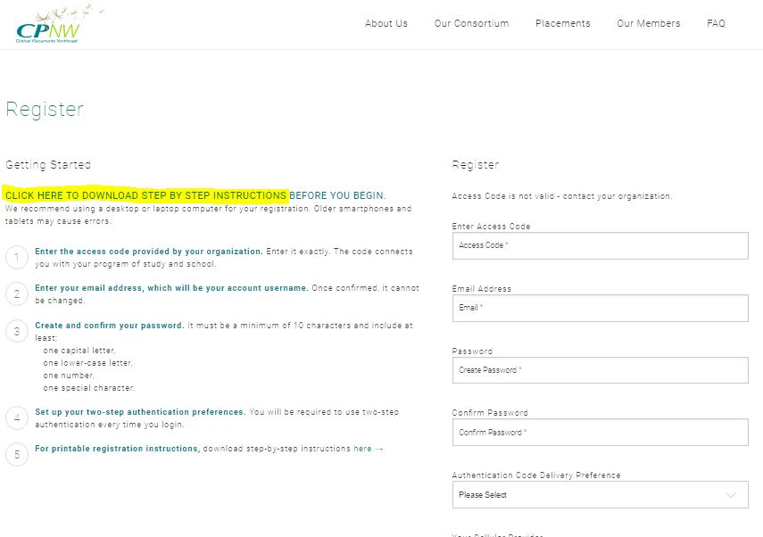

**STEP 4)** CPNW E-LEARNING MODULES

The school coordinator will request the CPNW Module Report from each student.

How to retrieve CPNW modules:

* + - Click on “My Dashboard”
    - Go to “Clinical Prerequisites” & click on “eLearning”
    - Students have the capability to send their module report to their school Coordinator once completed
    - Include this report into the student’s onboarding packet

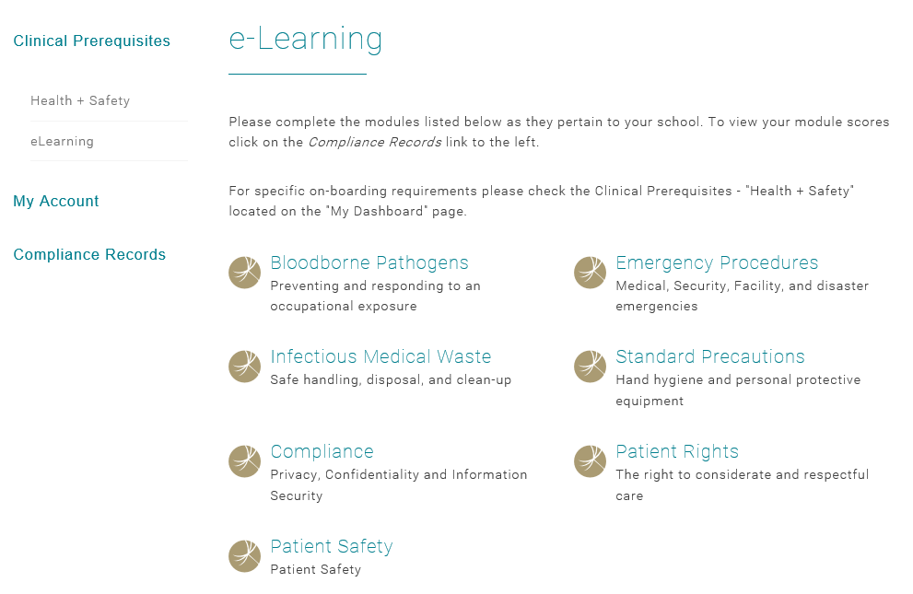

**STEP 5)** CLINICAL PASSPORT

It is the sole responsibility of the school coordinator to collect each student’s clinical passport & verify for accuracy (per contractual agreement). This form may NOT be completed by the student.

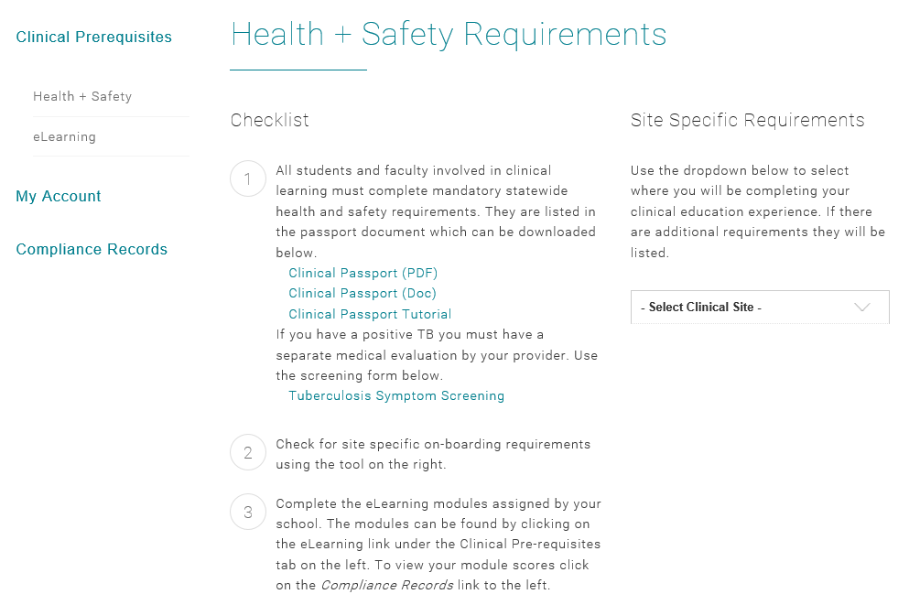

**STEP 6)** HOW TO RETRIEVE ONBOARDING DOCUMENTATION

Select the assigned organization & location for your student in order to retrieve site-specific, healthcare organization onboarding materials.



**NOTE**:

Once ALL onboarding requirements are complete, you will submit to the appropriate healthcare organization:

* **MultiCare Health System**: send onboarding materials to [OnboardingDocs@multicare.org](mailto:OnboardingDocs@multicare.org); Cc: [Jolita.Perez@multicare.org](mailto:Jolita.Perez@multicare.org)
* **CHI Franciscan**: send onboarding materials to [studentplacement@chifranciscan.org](mailto:studentplacement@chifranciscan.org)
* **Providence** **SW**:
* Nursing students/faculty send to [psphnursingeducation@providence.org](mailto:psphnursingeducation@providence.org)
* All other students/faculty send to [phsswprofpracticums@providence.org](mailto:phsswprofpracticums@providence.org)